W205 summer 2017 section 2 – Lab02 - K Iwasaki

1. ***List the HDFS contents of /user***

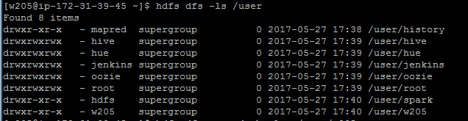

1. ***Inspect the output of the HDFS admin report and answer the following questions in a text file.***

***-To generate this, exit from the w205 user and type: sudo -u hdfs hdfs dfsadmin -report***

***Q1: How many live datanodes are there?*** Answer: 1

***Q2: How much non-DFS storage is used?*** Answer 5.05 GB

***Q3: How much DFS storage is used?*** Answer 137.38 MB

